**Jenkins Installation**

sudo apt-get update

sudo apt-get install openjdk-8-jdk

sudo apt-get install openjdk-8-jre

wget -q -O - <https://pkg.jenkins.io/debian-stable/jenkins.io.key> | sudo apt-key add -

sudo sh -c 'echo deb https://pkg.jenkins.io/debian-stable binary/ > /etc/apt/sources.list.d/jenkins.list'

sudo apt-get update

sudo apt-get install jenkins

service jenkins status >> to check status of Jenkins service.

Change jenkins user password as below:  
sudo su –  
passwd jenkins

Now login as jenkins user  
su – jenkins  
ssh-keygen

**Managing Nodes:  
Login to jenkins :** http://myServer:8080Step1:  
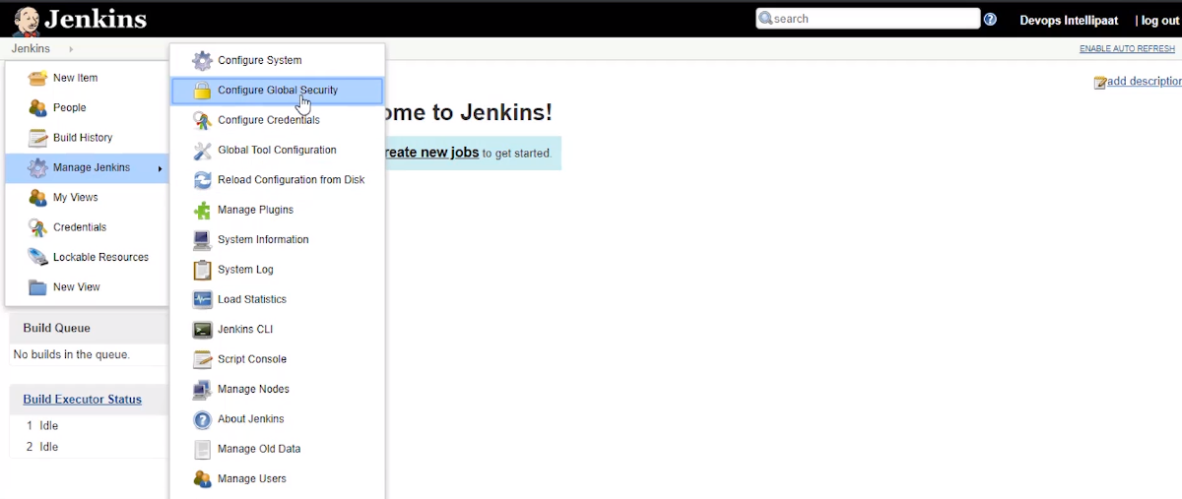

Here go to agents and there select random option.

**Step2:**

**Configure slave node:***sudo apt install software-properties-common apt-transport-https -y  
sudo add-apt-repository ppa:openjdk-r/ppa -y*

*sudo apt install openjdk-8-jdk -y*

*useradd -m -s /bin/bash jenkins  
passwd Jenkins*

*now login as jenkins user and:  
mkdir .ssh*

*vi authorized_keys*

*add the id_rsa.pub contents from master jenkins user to this location*

***now test connectivity from master :*** *ssh jenkins@slave*

***Now add credentials in jenkins:***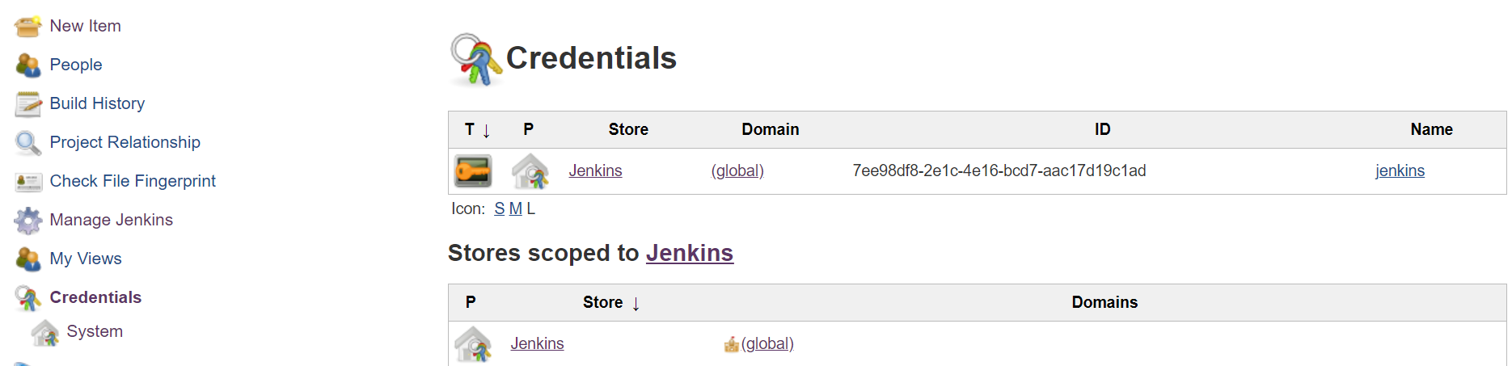

***Select global and add credentials button:***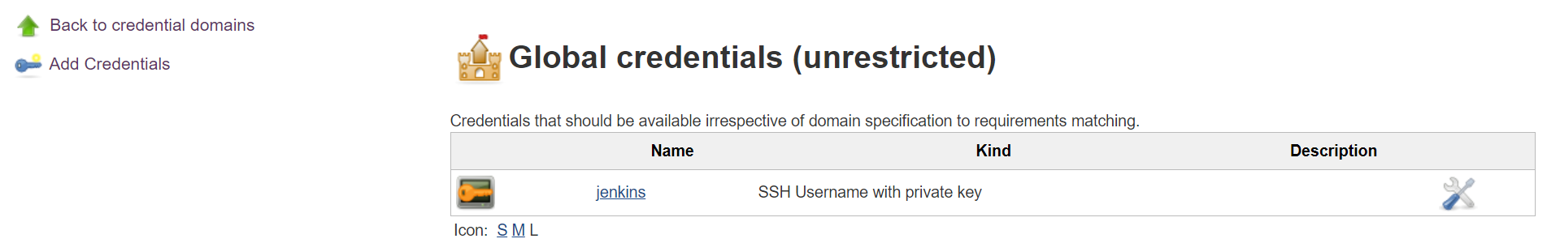

***Now do as per the screenshot and add id_rsa private key contents in key box***

***And click ok:***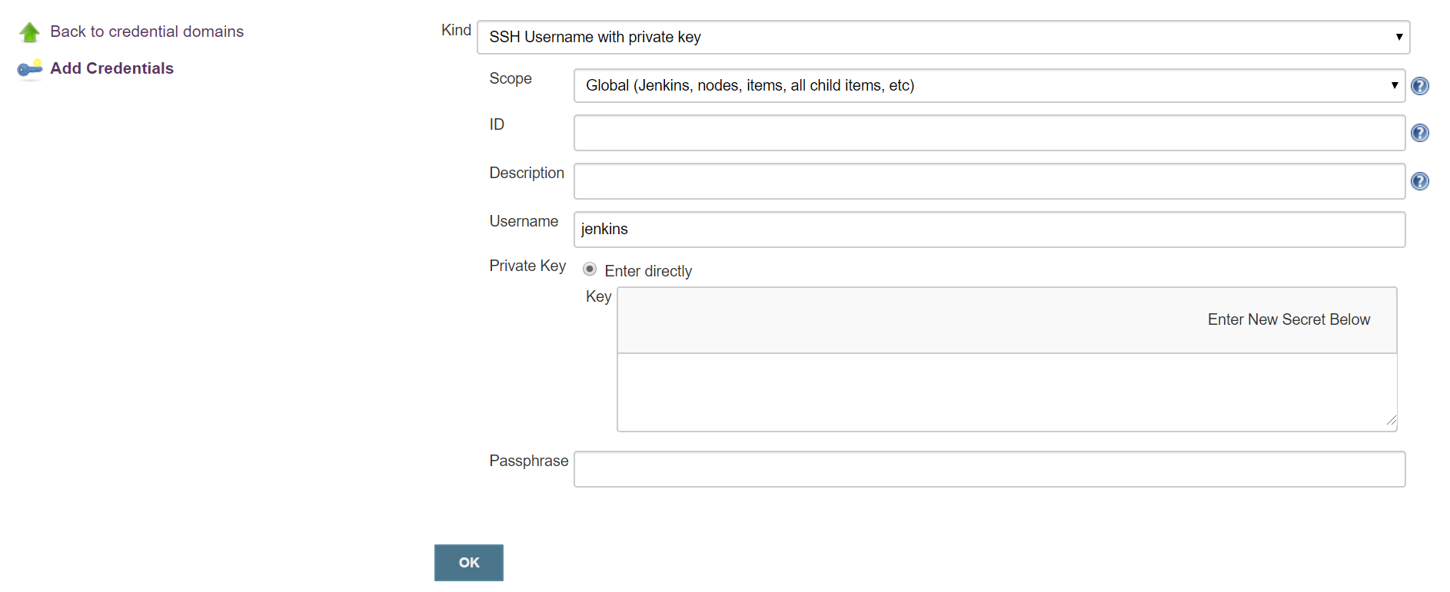 **Go to manage nodes and :**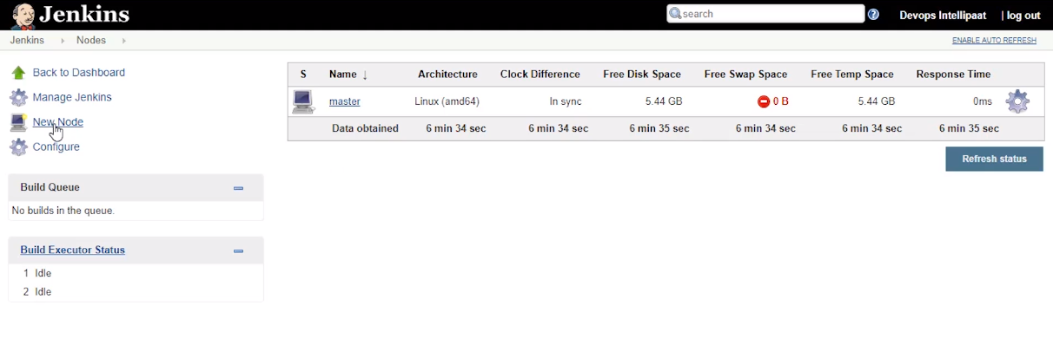

**And do as per the screenshot:**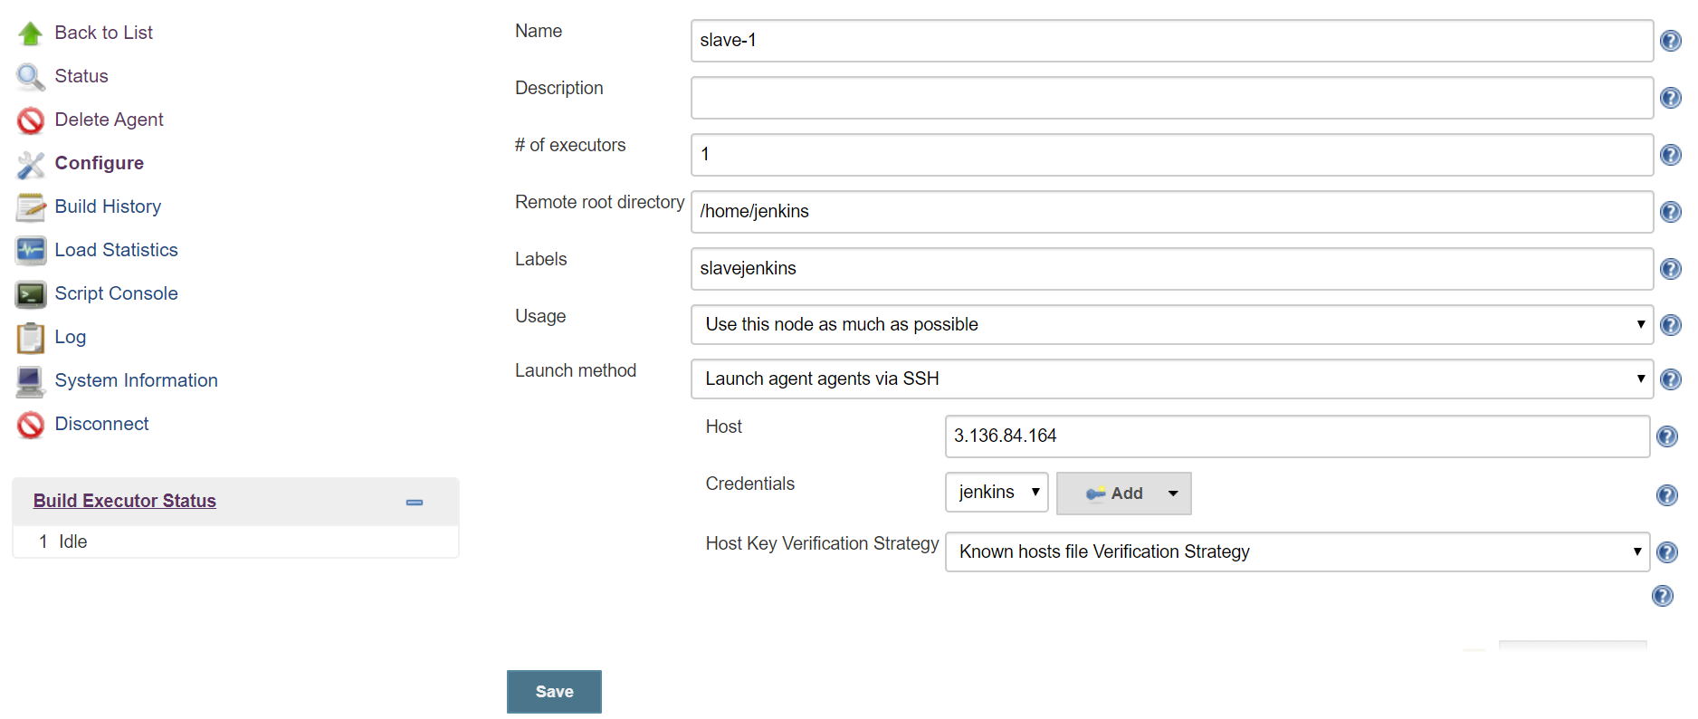

Step 3:  
Install and configure ansible in Slave node.